The entire kit includes a set of EL GLOW GAUGE and an Inverter/Lighting controller.

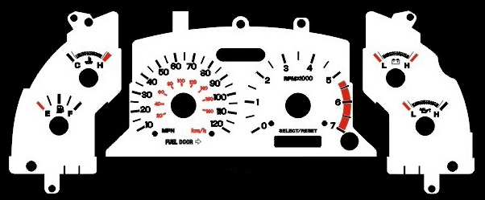

Day

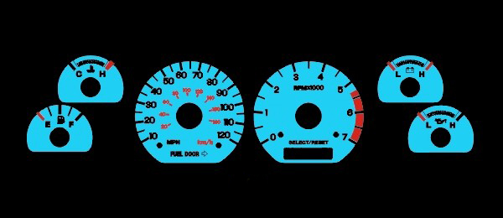

Night

There are 2 styles of Inverter.Anglog 2-color Inverter and Digital 6-color Inverter.

You can choose either one of them to EL GLOW GAUGE.
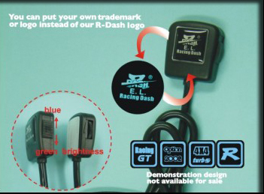 | 