2

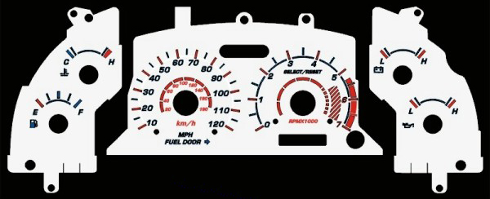

Day

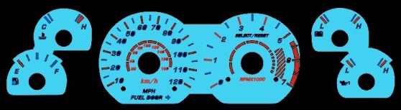

Night:Stage1:Background light up.

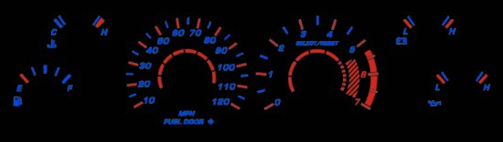

Night:Stage2:Only lines and numbers light up.
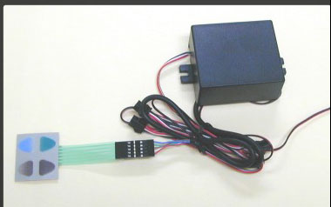

:Digital keypad controller
:5 steps color changeble over the halos

:Color switch does not affect apparently at stage 2 lighting.

